$$PCA$$

$PCA : Principal Component Analysis$

$It is a dimension reduction technique$

$Dimensions means features or variables or columns$

$We already know there two main problems while devlop the model$

$If we add more features then the model might become overfit$

$we also excpect input features are independent each other$

$To avoid this to perform feature selection methods$

$PCA Speciality:$

$PCA will use all original features, It will not remove the features$

$PCA will create new dimensions of data , which means it completely create a$

$$new data which includes all original features$$

$The new data features less than the original data features$

$$in this way it can reduce features or dimensions$$

$The new data columns are indepedent each other$

$$Before apply ML model,$$

$You can pass original data$

$Z-transformaton or Normalized data \left(only on numerical columns\right)$

$We can apply PCA and pass the data$

$$PCA will reduce the dimensions with out drop the original features, and the new data features$$

$$are independent each other$$

$$How to do?$$

$Covariance concept:$

$$Covariance means , it will give the relationship between varaibles$$

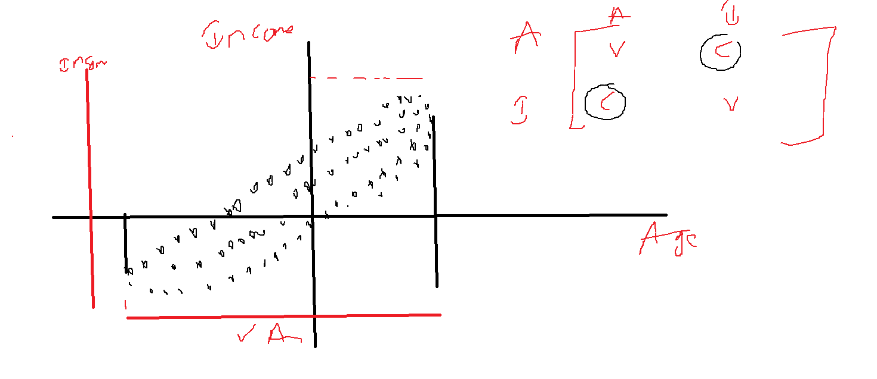

$$In above figure , there are two columns age and income both are correlated or dependent each other$$

$$Data varying along the both axis almost equal , It is very hard to select one feature$$

$$If data variance along one axis more than another axis, then we can choose one column of data$$

$$which is having the more variance.$$

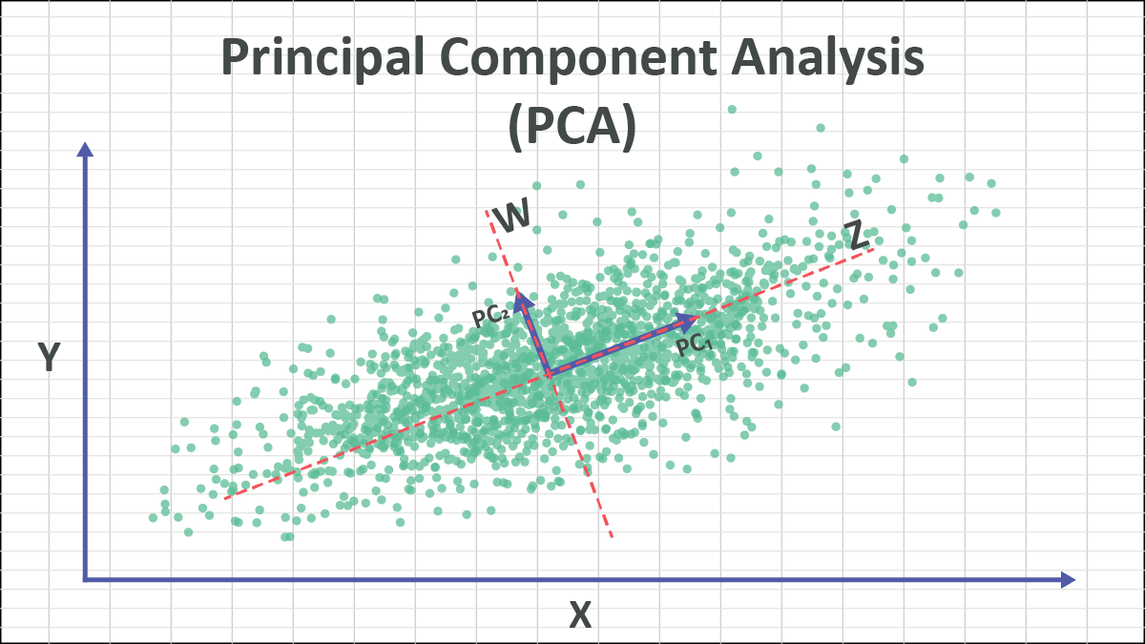

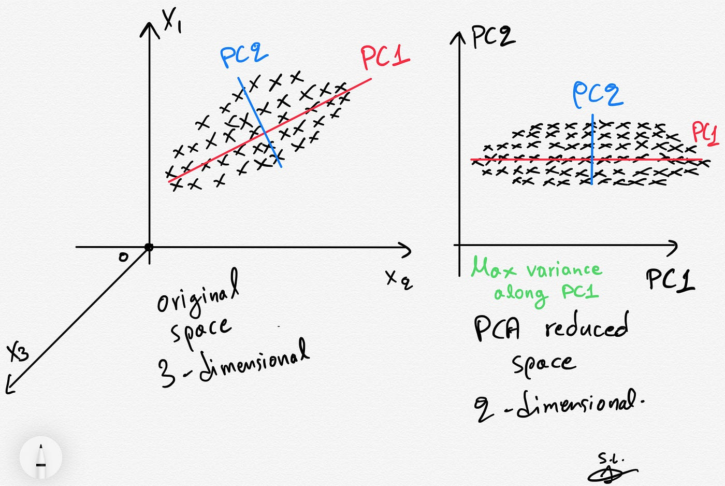

can you please explain one more time how to add , remove and dont remove dimensions ?

sir why its required to convert 3d to 2d

increase the performance right sir

what is the reason for overfitting:

ultimate goal: increase the performance right sir

feature selection: Select the important features

3D to 2D ( Feature selection)

3D to 2D ( information might loss)

In PCA we are using original columns , so data loss will not happen

which scenario (ML) we need to use/select PCA ?

$$Rotation of the data:$$

$$when we rotate a new set of dimensions will create, that dimensions are called a$$

$$Principal comonents \left(PC^{'}s\right)$$

$$POINT-1$$

$$Originally we have two columns : Age and income$$

$$After apply PCA it will create new two columns: PC_{1}, PC_{2}$$

$$POINT-2:$$

$$PC_{1}=b_{11}*Age+b_{12}*Income$$

$$PC_{2}=b_{21}*Age+b_{22}*Income$$

$$POINT-3:$$

$$Originally the we have a covariance along Age and income$$

$$After apply PCA we dont have a covariance along PC_{1},PC_{2}$$

$$This concludes the data feature are orthogonal$$

$$POINT-4:$$

$$Originally we have equal data variance along the Age and income$$

$$After apply PCA we dont have equal variane along PC_{1} and PC_{2}$$

$$then we select the one feature from PC_{1} and PC_{2} which is having the more variance$$

$$Var\left(Age\right)(50\%)+Var\left(Income\right)(50\%)=100\%$$

$$Var\left(PC_{1}\right)(97\%)+Var\left(PC_{2}\right)(3\%)=100\%$$

$$Var\left(PC_{1}\right)> Var\left(PC_{2}\right): we can select only PC_{1}$$

$$now 2d reduce to 1D, also data not loss$$

$$suppose we have x_{1,}x_{2},x_{3},….x_{10} are original columns$$

$$after apply PCA we have new columns: PC_{1},PC_{2},….PC_{10}$$

$$PC_{1}:90+PC_{2}:5+PC_{3}:2+……….+PC_{10}$$

$$PC_{1}=b_{11}*x_{1}+b_{12}*x_{2}+…….+b_{11o}x_{1o}$$

So which side we need rotate ?

first of all we not removing the data, we are creating a new data

new data includes original

$$TWO important questions$$

$In which direction data becomes more vary, how we are calculating the direction$

$How much the variance should happen in that direction$

$$First choose the direction , how much want to travel$$

$$Concept Name:Eigen value and Eigen Vector$$

$$Eigen Vector: Whcih direction you want to go ( Axis)$$

$$Eigen value: How much distance need to travel ( Data variance)$$

$$Ax=λx$$

$$A=Covaraince matrix$$

$$Suppose we have 3 columns , covariance matrix: 3X3$$

$$For 3X3 matrics will get how many roots$$

$$x=eigen vector$$

$$λ=eigen value$$

$$Ax=λx$$

$$Ax-λx=0$$

$$x\left(A-λ\right)=0$$

$$\left|A-λI\right|=0$$

$$From the covariance matrix will get eigen value and eigen vector$$

$$Eigen vectors indicates the direction$$

$$Eigen values indeicates amount of variance$$

$$The dot product of eigen vectors=1 or 0$$

$$Problem:$$

$We already know there two main problems while devlop the model$

$If we add more features then the model might become overfit$

$we also excpect input features are independent each other$

$$Solution$$

$PCA Speciality:$

$PCA will use all original features, It will not remove the features$

$PCA will create new dimensions of data , which means it completely create a$

$$new data which includes all original features$$

$The new data features less than the original data features$

$$in this way it can reduce features or dimensions$$

$The new data columns are indepedent each other$

$$Concept Name:Eigen value and Eigen Vector$$

$$Eigen Vector: Whcih direction you want to go ( Axis)$$

$$Eigen value: How much distance need to travel ( Data variance)$$

$$POINT-1$$

$$Originally we have two columns : Age and income$$

$$After apply PCA it will create new two columns: PC_{1}, PC_{2}$$

$$POINT-2:$$

$$PC_{1}=eigen vector_{1}*Age+ev_{1}*Income$$

$$PC_{2}=ev_{2}*Age+ev_{2}*Income$$

$$New data=Eigen vector*Old data$$

$$POINT-3:$$

$$Originally the we have a covariance along Age and income$$

$$After apply PCA we dont have a covariance along PC_{1},PC_{2}$$

$$This concludes the data feature are orthogonal$$

$$covariance should be zero$$

$$POINT-4:$$

$$Originally we have equal data variance along the Age and income$$

$$After apply PCA we dont have equal variane along PC_{1} and PC_{2}$$

$$then we select the one feature from PC_{1} and PC_{2} which is having the more variance$$

**how are we getting eigen vectors sir ????**

$$Curse of dimensionality:$$

$$More features=== >Overfit the model$$

$$process=== >Time, infreastructure$$

$$Take one image size=512X512=2621444$$